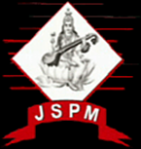 | JSPM’s  RAJARSHI SHAHU COLLEGE OF ENGINEERING  TATHAWADE, PUNE-33  (An Autonomous Institute Affiliated to SavitribaiPhule Pune University,Pune) | 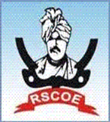

A.Statement of Clear Goal, Use of appropriate methods, Significance of results, Effective presentation

Name of the Course: Data Structures and Algorithms
Name of the Faculty: Dr. Priya Karemore
Name of the Innovative Method used: Role play activity
Name of the topic: B tree, B+ tree
Statement of Clear Goal: To help students understand topics better by using Role play activity in teaching, so they can learn anytime, discuss difficult concepts with peers , and enjoy learning by working in a team.
The aim of this role play is to enable students to learn how B tree and B+ tree as data structures play major role to implement data structure efficiently. It promotes active learning and collaboration while building upon fundamental ideas.
Significance of result: The role play activity enriched students conceptual knowledge by converting theoretical concepts into live interactions. It encouraged participation and built communication and collaborative skills among students.
Peer Review and Critique (Feedback):
Effective Presentation (Screenshot):
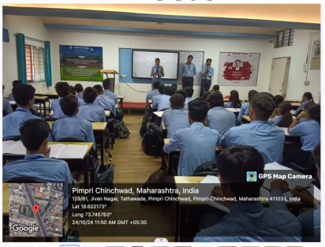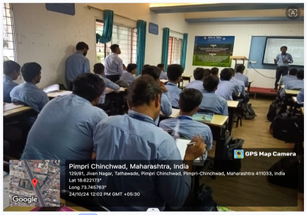

Peer Review and Critique (Feedback):

Feedback link: https://forms.gle/Z3DDSnsaFTGXtQE4A

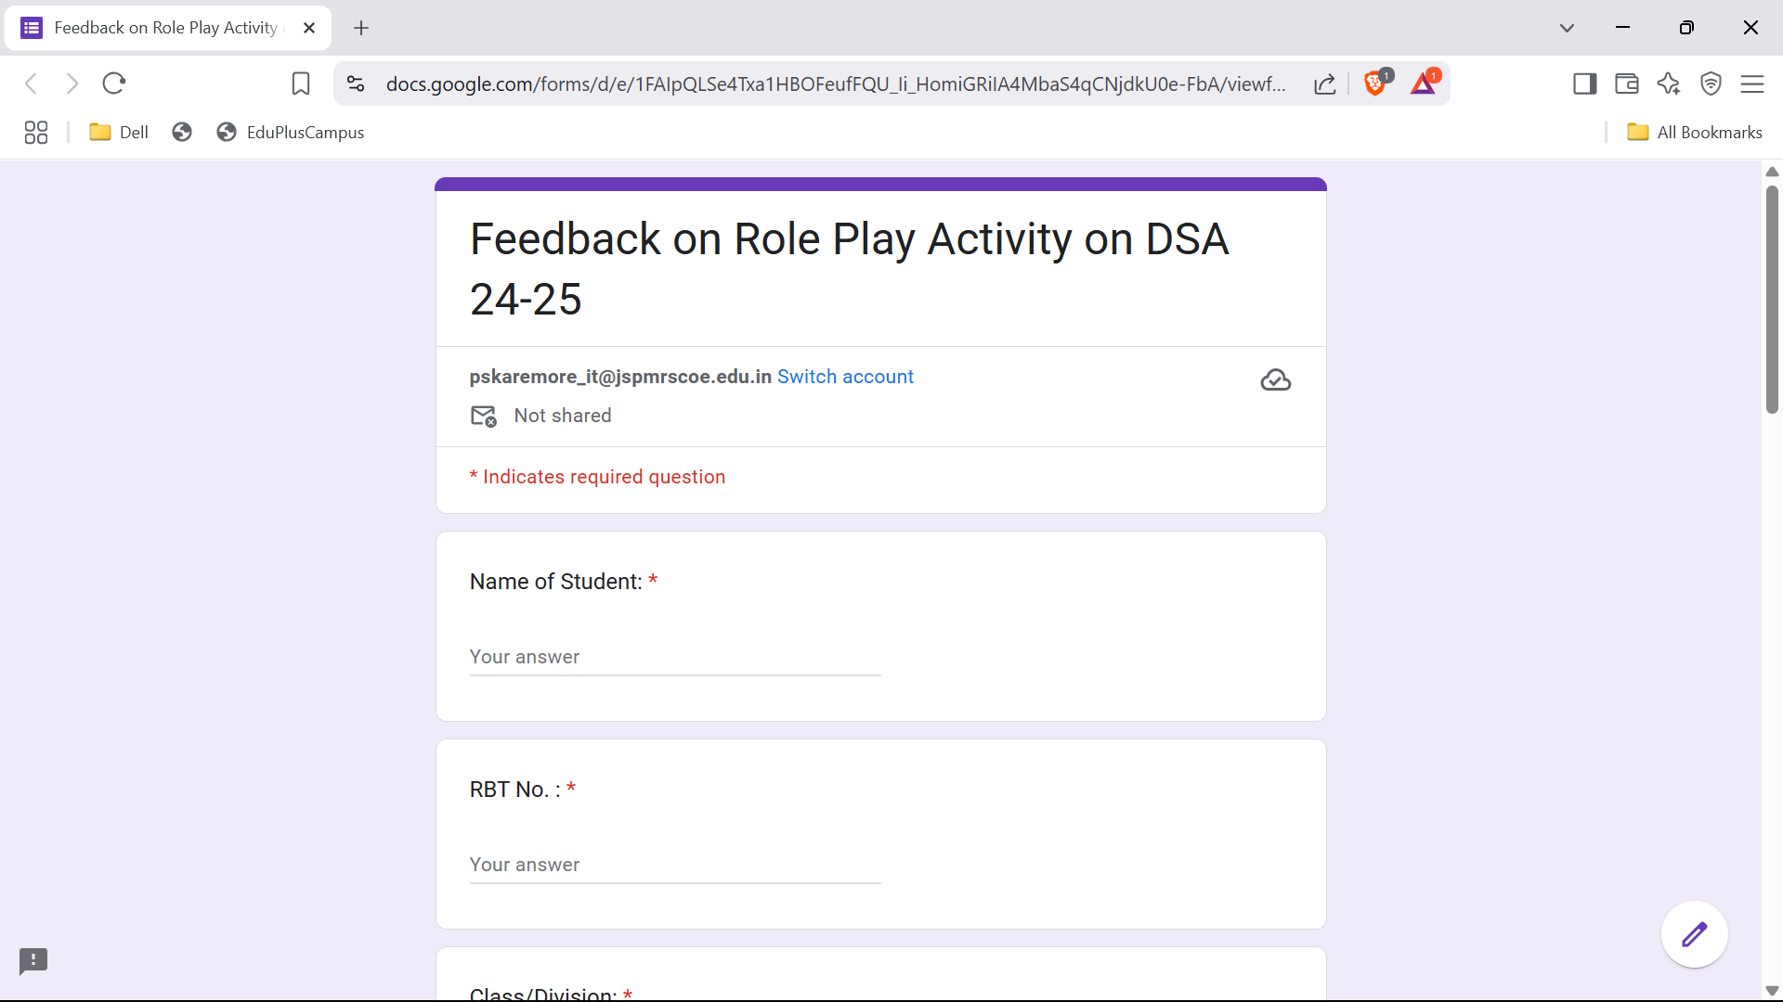

B. Availability of work related to Innovation by Faculty in Teaching and Learning is on Institute website.

https://www.jspmrscoe.edu.in/information-technology/innovation-practices

C. Availability of work for peer review and critique.

https://github.com/jspmIt/PSK

D: Reproducibility and Reusability by other scholars for further development

- Clear structure and instructions are documented.
- Roles and scenarios are well-defined and standardized.
- Assessment criteria or learning goals have kept transparent.
- Modular scenarios that can be customized.

Sr.No | Innovation Used | Details of User | Purpose of  Reproducibility and Reusability
1. | Role Play activity | Dr.Priya Karemore | To encourage knowledge sharing and collaboration and team work.

Course Co-ordinator Module Co-ordinator HOD

Dr.Priya Karemore Dr. D.T.Salunke Dr. Nihar M. Ranjan

